# How Soil Moisture Sensor Works and Interface it with Arduino

When you hear the term “smart garden,” one of the first things that comes to mind is a system that monitors the moisture level of the soil and automatically supplies the necessary amount of water to the plants.

With this system, plants can be watered only when required, avoiding over- or under-watering.

If you want to build such a system, you will undoubtedly require a Soil Moisture Sensor.

## How Does a Soil Moisture Sensor Work?

The soil moisture sensor operates in a straightforward manner.

The fork-shaped probe with two exposed conductors acts as a variable resistor (similar to a potentiometer) whose resistance varies with the soil’s moisture content.



This resistance varies inversely with soil moisture:

* The more water in the soil, the better the conductivity and the lower the resistance.
* The less water in the soil, the lower the conductivity and thus the higher the resistance.

The sensor produces an output voltage according to the resistance, which by measuring we can determine the soil moisture level.

Technical specification:

| **Specification** | **Value** |
| --- | --- |
| Sensor Type | Soil Moisture Sensor |
| Measurement Method | Capacitive Sensing |
| Soil Moisture Range | 0% to 100% (Volumetric) |
| Operating Voltage | 3.3V - 5V |
| Output Type | Analog Voltage or Digital |
| Operating Temperature | -10°C to +70°C |
| Probe Length | Varies (e.g., 5cm to 20cm) |

## Hardware Overview

A typical soil moisture sensor consists of two parts.

### The Probe

The sensor includes a fork-shaped probe with two exposed conductors that is inserted into the soil or wherever the moisture content is to be measured.

As previously stated, it acts as a variable resistor, with resistance varying according to soil moisture.

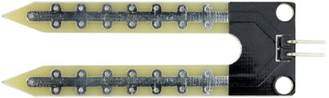

### The Module

In addition, the sensor includes an electronic module that connects the probe to the Arduino.

The module generates an output voltage based on the resistance of the probe, which is available at an Analog Output (AO) pin.

The same signal is fed to an LM393 High Precision Comparator, which digitizes it and makes it available at a Digital Output (DO) pin.

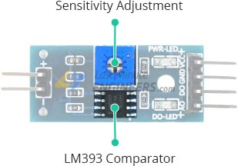

The module includes a potentiometer for adjusting the sensitivity of the digital output (DO).

You can use it to set a threshold, so that when the soil moisture level exceeds the threshold, the module outputs LOW otherwise HIGH.

This setup is very useful for triggering an action when a certain threshold is reached. For example, if the moisture level in the soil exceeds a certain threshold, you can activate a relay to start watering the plant.

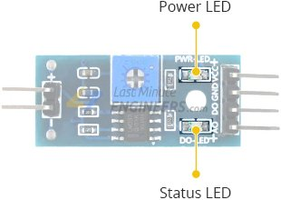

The module also includes two LEDs. The Power LED illuminates when the module is turned on, and the Status LED illuminates when the soil moisture level exceeds the threshold value.

## Soil Moisture Sensor Pinout

The soil moisture sensor is extremely simple to use and only requires four pins to connect.

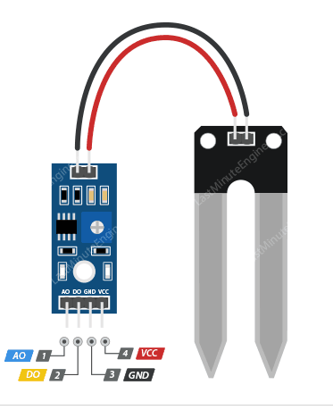

AO (Analog Output) generates analog output voltage proportional to the soil moisture level, so a higher level results in a higher voltage and a lower level results in a lower voltage.

DO (Digital Output) indicates whether the soil moisture level is within the limit. D0 becomes LOW when the moisture level exceeds the threshold value (as set by the potentiometer), and HIGH otherwise.

VCC supplies power to the sensor. It is recommended that the sensor be powered from 3.3V to 5V. Please keep in mind that the analog output will vary depending on the voltage supplied to the sensor.

GND is the ground pin.

## Measuring Soil Moisture using Analog Output (A0)

**Components Required:**

1. Soil moisture sensor
2. Arduino Uno R3
3. 5 x LEDs (Used for Level Indication purposes only)
4. 100 Ohm resistor
5. Jumper wires

**Setup:**

1. Connect the VCC pin of the sensor to the 5V pin of the Arduino.
2. Connect the GND pin of the sensor to the GND pin of the Arduino.
3. Connect the SIG (signal) pin of the sensor to the A0 (Analog) pin of Arduino.
4. Navigate to **Tools** in Arduino software and select board and port.
5. Verify and compile the code, then upload the code to the Arduino Uno R3 board.
6. Monitor the output in the Serial monitor (Set the baud rate as 9600). To open Serial monitor **Tools>Serial Monitor** or **(Ctrl+Shift+M)**.

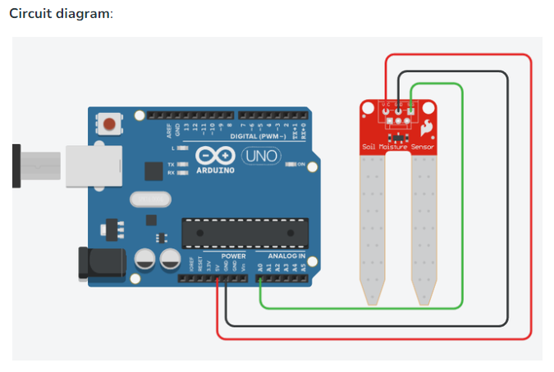

**Arduino code for Analog Reading (output in the serial monitor):**

void setup()

{

// Set the serial monitor baudrate to 9600

Serial.begin(9600);

}

void loop()

{

// Variable to store ADC value ( 0 to 1023 )

int level;

// analogRead function returns the integer 10 bit integer (0 to 1023)

level = analogRead(0);

// Print text in serial monitor

Serial.println("Analog value:");

// Print analog value in serial monitor

Serial.println(level);

}

When you run the sketch, you should see readings similar to the ones below:

* When the soil is dry (around 850)
* When the soil is completely saturated (around 400)

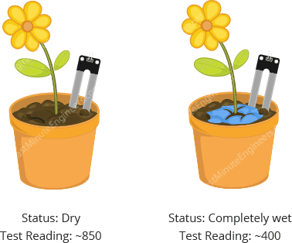

This test may require some trial and error. Once you have the readings, you can use them as a threshold to trigger an action.